Architecture of 2G, 3G and 4G network:

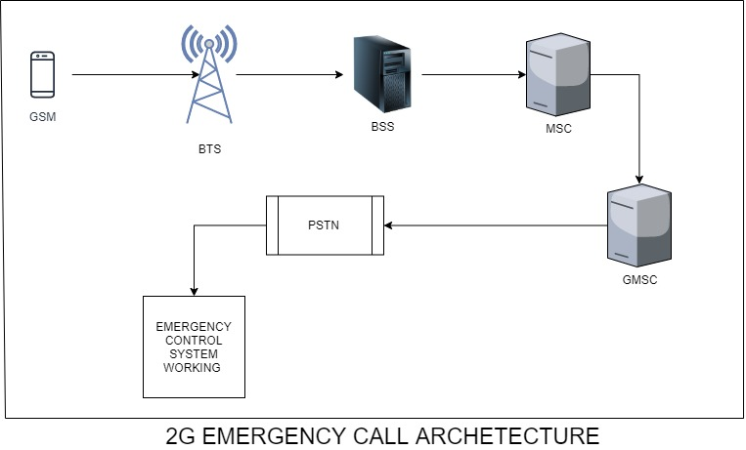

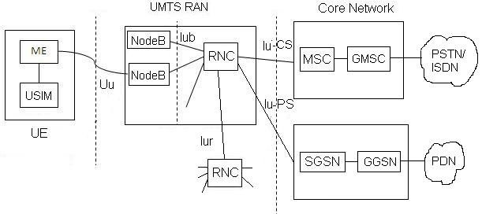

3G architecture the only change between the 2G and 3G is that BTS is replaced with NodeB and BSS with RNC .

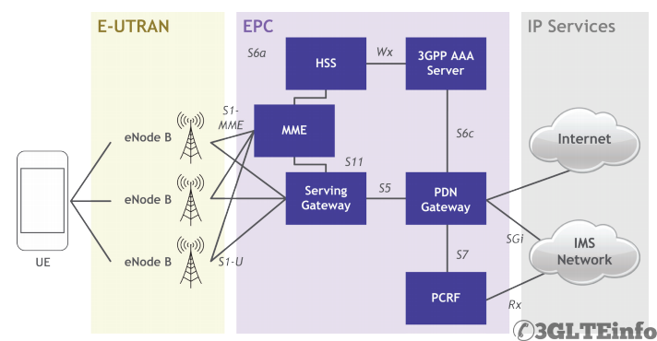

In this LTE system the BTS and BSS completely converted in one node i.e. eNodeB it is used for Radio resource management.

1. MME(mobility management entity): Function of MME are
   1. Authentication
   2. Choose serving gateway
2. HSS (home subscriber server):
   1. It contains the user database like IMSI, AUC etc.
   2. It also handle the subscription details of the user.
   3. User identification
   4. Addressing
3. Serving gateway: it forwards the user data packets.
4. PDN GATEWAY: Packet data network gateway
   1. It allocate the IP to the UE
5. PCRF (POLICY AND CHARGING RULE FUNCTION):
   1. Charging or accounting.

**Algorithm for 2G/3G:**

1. Step 1: A MS can make a call even in Emergency call time.
2. Step 2: The call will initiate just like the Emergency call.
3. Step 3: RADIO, LAPDm, RR protocols works same as they work in emergency call procedure.
4. Step 4: After successful communication between the MS and MSC, CM request send.
5. Step 5: Change MM protocol message type content from 0100 to 0110.
6. Step 6: MSC forwards the DER message to AAA proxy for authentication, authorization and accounting.
7. Step 7: AAA proxy sends a DER message to SPSTN.
8. Step 8: SPSTN checks the IMSI of the user and separate out the MNC and MCC.
9. Step 9: By the help of these MNC and MCC it will create a new DER message consists of the content that will be important for AAA SERVER for authenticate its user.
10. Step 10: HPLMN authenticate its user and sends back a DER reply message to SPSTN.
11. Step 11: SPSTN forward this message to AAA proxy and AAA proxy to MSC.
12. Step 12: A new DER message sends to SPSTN having the content that are needed for generating the CDRs.
13. Step 13: SPSTN then send a DER message to HPLMN AAA server consist of the call connecting time.
14. Step 14: AAA server send the DER reply message to SPSTN. SPSTN forward this message to AAA proxy.
15. STEP 15: After the call is disconnected the AAA proxy again send a message to the SPSTN consisting of call disconnection time.
16. Step 16: SPSTN initiates the process of generating the CDRs and also send a message to the AAA server consists of call disconnection time.
17. Step 17: AAA server sends the reply for the message received.
18. Step 18: After the generation of complete CDRs the SPSTN forward the CDRs to AAA server and proxy both.
19. Step 19: After receiving the CDRs the AAA server and proxy both sends the receiving of the CDRs.

**Algorithm for 4G:**



1. Step 1: A MS can make a call even in Emergency call time.
2. Step 2: The call will initiate just like the Emergency call.
3. Step 3: RADIO, LAPDm, RR protocols works same as they work in emergency call procedure. RR protocol will be complete with the help of e-NodeB.
4. Step 4: After successful communication between the UE and MME, CM request send.
5. Step 5: Change MM protocol message type content from 0100 to 0110.
6. Step 6: MME send the authentication request to the HSS.
7. Step 7: HSS forwards the DER message to AAA proxy for authentication from the HPLMN of the user.
8. Step 8: AAA proxy sends a DER message to SPSTN.
9. Step 9: SPSTN checks the IMSI of the user and separate out the MNC and MCC.
10. Step 10: By the help of these MNC and MCC it will create a new DER message consists of the content that will be important for AAA SERVER for authenticate its user.
11. Step 11: AAA server authenticate its user and sends back a DER reply message to SPSTN.
12. Step 12: SPSTN forward this message to AAA proxy and AAA proxy forwards it to the HSS and HSS to the MME.
13. Step 13: After the successful authentication MME forwards the calling request to the serving gateway and serving gateway to PDN gateway.
14. Step 14: Now PDN gateway allocates a IP address to the user and requests the PCRF to start the accounting of the user.
15. Step 15: Now the PCRF send a DER REQUEST message to the AAA proxy provide the sufficient information of the user to generate the accounting.
16. Step 16: AAA proxy generates the DER reply message and provide the information to PCRF. Then PCRF generates a new message consists of the call connection time, IMSI of the user and the IP address allocated by the PDN gateway.
17. Step 17: AAA proxy send this DER message to SPSTN. SPSTN forward this message to AAA server.
18. Step 18: AAA server generates the DER reply message and send it to SPSTN. Then SPSTN forward this message to the PCRF.
19. Step 19: When the call disconnected the PCRF generates another DER message to the AAA proxy consists of call runtime and call disconnection time.
20. Step 20: After this AAA proxy forwards this message to the SPSTN to generate the CDRs.
21. Step 21: SPSTN sends a DER message to AAA server consists of call disconnection time and start generating the CDRs.
22. Step 22: After generating the CDRs the SPSTN forward it to the both PLMNS.